**CS6612 – Compiler Lab**

**Ex no : 3 Name : Sreedhar V**

**Date : 20.02.2021 Reg no: 185001161**

**Specification**

Write a program in C to find whether the given grammar is Left Recursive or not. If it is found to be left recursive, convert the grammar in such a way that the left recursion is removed.

**Code**

#include<stdio.h>

#include<string.h>

#include<stdlib.h>

void detect(char prod[][30],int n)

{

    for(int i=0;i<n;++i)

   {

        char p = prod[i][0];

        if(p==prod[i][3])

        {

            char *token = strtok(prod[i],"|");

            char alpha[10];

            int j=0;

            for(int itr=4;itr<strlen(token);itr++)

                alpha[j++]=token[itr];

            char beta[10][20];

            j=0;

            char buffer[20];

            while(token!=NULL)

            {

                strcpy(buffer,token);

                token=strtok(NULL,"|");

                if(token!=NULL)

                    strcpy(beta[j++],token);

                else

                    strcpy(beta[j++],buffer);

            }

            j--;

            if(!j)

            {

                printf("\n%c -> %c'",p,p);

                char alpha[10];

                int j=0;

                for(int itr=4;itr<strlen(prod[i]);itr++)

                    alpha[j++]=prod[i][itr];

                printf("\n%c'->%s %c' | (null)\n",p,alpha,p);

                continue;

            }

            printf("\n%c ->%s %c'",p,beta[0],p);

            for(int i=1;i<j;i++)

                printf("|%s %c'",beta[i],p);

            printf("\n%c'->%s %c' | (null)\n",p,alpha,p);

        }

        else

            printf("\n%s\n",prod[i]);

    }

}

int main()

{

    int n=0;

    char prod[20][30];

    printf("\n\tLeft Recursion_Elimation\n");

    int i=0;

    FILE *file = fopen("input.txt","r");

    char c;

    printf("\nGiven grammar\n");

    while(fscanf(file,"%c",&c)==1)

    {

        if(c=='\n')

        {

            prod[n][i]='\0';

            printf("\n%s\n",prod[n]);

            n++;

            i=0;

        }

        else

        {

            prod[n][i]=c;

            i++;

        }

    }

    printf("The set of productions in grammer after left recursion:\n");

    detect(prod,n);

    printf("\n");

    return 0;

}

*(Sample input file)*

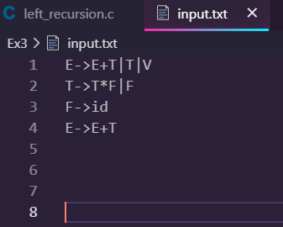

*(Output)*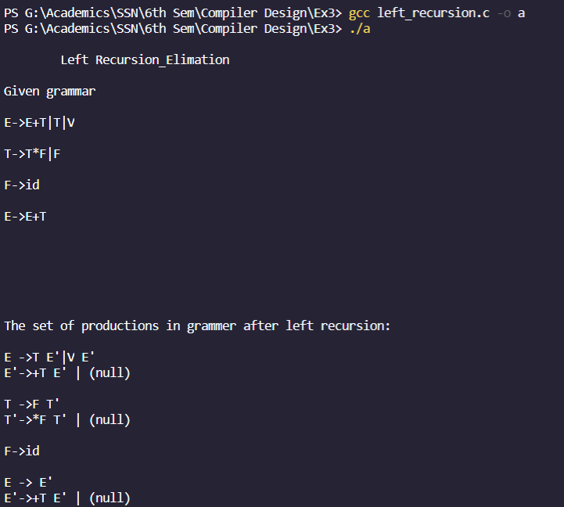

**Learning Outcome:**

* I’ve learnt how to identify the left recursion in the production of the grammar and construct a new grammar with removing such productions.
* I’ve learnt how to implement the same using C code which identifies whether the grammar is left recursive or not and converts the grammar in a such a way that the left recursion is removed.
* I’ve learnt the Elimination of Immediate Left Recursion using the rule if the production is in the form A->Aα | β, then A-> βA’,A’->Ɛ | αA’.